**Student registration system**

**Date:**

2023 - 2022

**Members:**

Zahra Albarrak 222416060

Salma Aljabr 222411211

Noor Alshaqaq 221432807

**# Project Description:**

This system is used to manage student' registration data and accept 1000 student record.

**Project Data:#**

**This program should be able to store:**

1.Student details (ID, First name, Family name, email address).

2.Course details (name, ID).

**# Project functions:**

. Add new student1

2. Add new course for a student

3. Search for a student

4. Delete student record

5. Delete course from a student

6. Update student record

7. Update course for a student

8. Display all students

9. Quit Program

**# Project User Manual:**

1.**Add new student** is used to add new student

by filling up student details and it will

store the record.

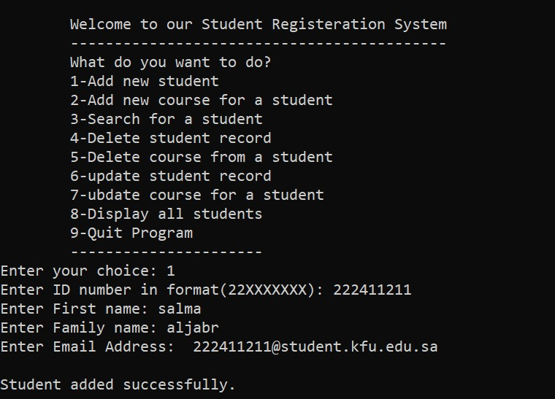

2.**Add new course for a student** is used add new course for a specific student by choosing one from the shown list and fill its details and then it will store the record.

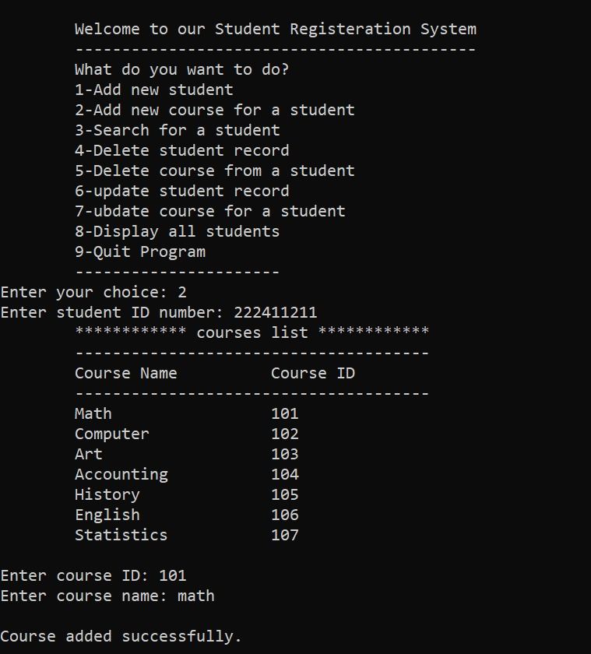

**3.search for a student** is used to search

for a specific student by entering his ID number and then it will display the data recorded about this student.

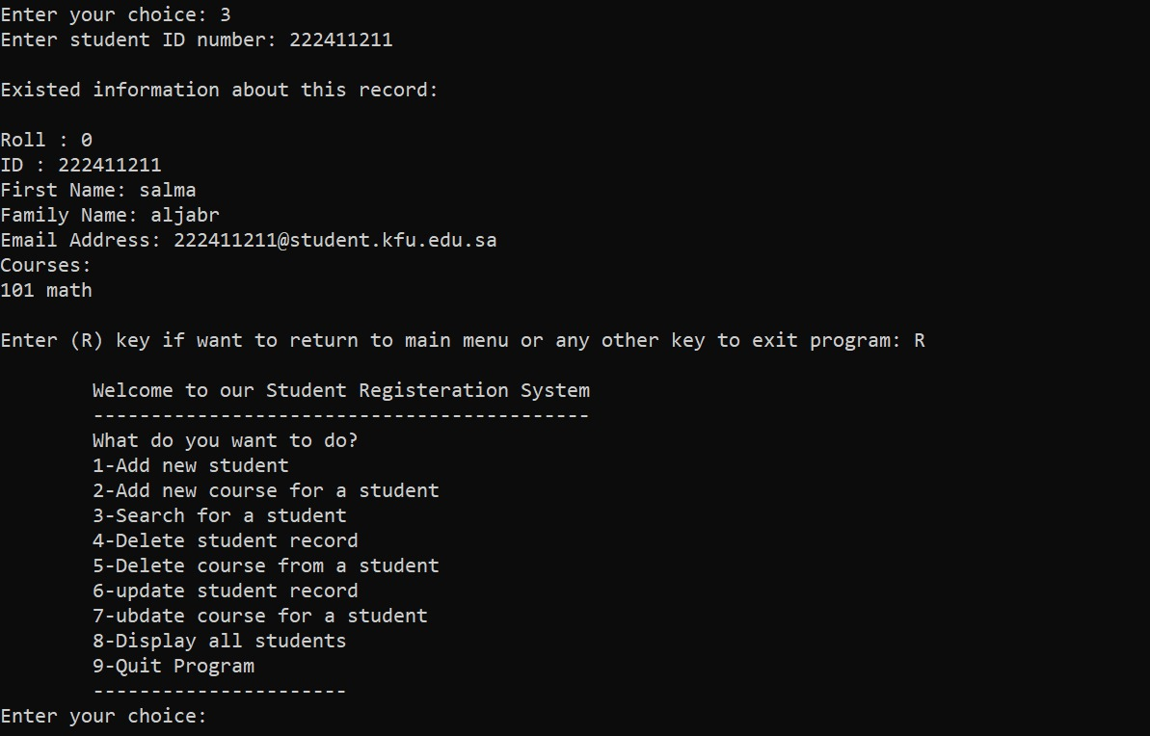

**4.Delete student record** is used to delete

a specific student record by entering his ID number.

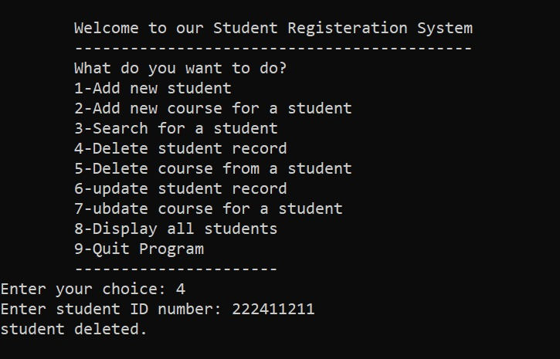

**5.Delete course for a student** is used to delete

specific course for a specific student by entering his ID number and course ID number.

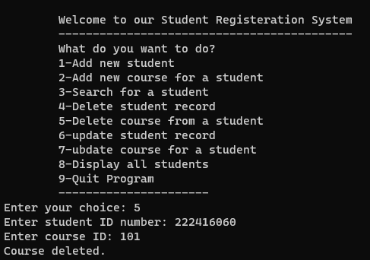

**6.Update student record** is used to update

specific student record by entering his ID number and then it will search about it and display the data recorded and ask to enter new data for this student.

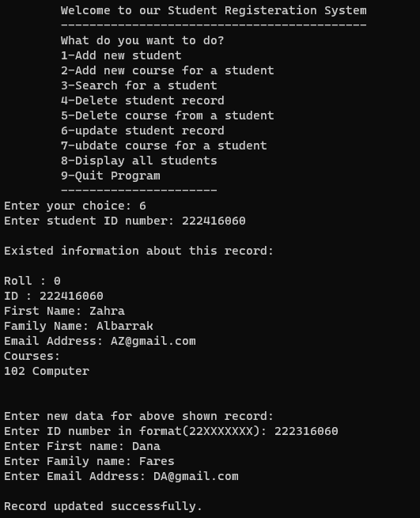

**7.Update course for a student** is used to update

specific course that was added for a specific student record by entering student ID number and then it will search about it and display the courses recorded for that student and then ask to enter course ID number to be updated and entering new course data to be recorded instead.

**8.Display all students** is used to display a table that contains all students data recorded.

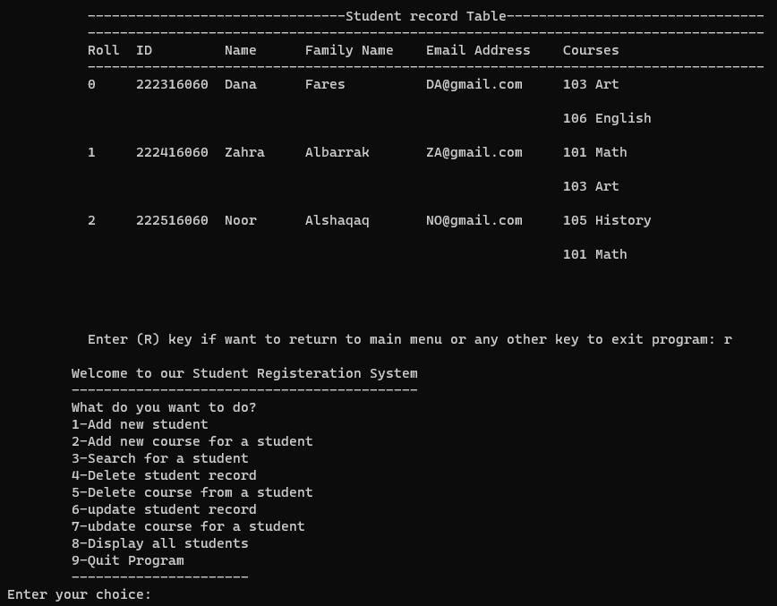

**9.Quit program** is used to exit the system.

